Project Design Phase-II
Solution Requirements (Functional & Non-functional)

Date | 30 September 2026
Team ID | SWTID-2026-8886
Project Name | Implement Client Script and UI Policy for Incident
Maximum Marks | 4 Marks

Functional Requirements:
Following are the functional requirements of the proposed solution.
FR No. | Functional Requirement (Epic) | Sub Requirement (Story / Sub-Task)
FR-1 | High impact controls | When Impact=1, apply policy on load and change.
FR-2 | Routing required | Assignment group and Assigned to become mandatory at Impact=1.
FR-3 | Urgency default | Set Urgency=1 when Impact changes to 1.
FR-4 | Save validation | Block high-impact submission if either routing field is empty.
FR-5 | List edit workflow | Decline direct State list edits and prompt the user to open the form.
FR-6 | Reverse behavior | When Impact is not 1, reverse mandatory and read-only settings without clearing values.

Non-functional Requirements:
Following are the non-functional requirements of the proposed solution.
FR No. | Non-Functional Requirement | Description
NFR-1 | Usability | Field-level errors and brief info message.
NFR-2 | Security | UI scripts guide users; server rules enforce policy beyond the UI.
NFR-3 | Reliability | Test create, update, reversal, list, and form paths.
NFR-4 | Performance | No external API calls; measure in instance before rollout.
NFR-5 | Availability | Depends on ServiceNow instance availability; no added service.
NFR-6 | Scalability | Uses native Incident form controls; no new data store or service.

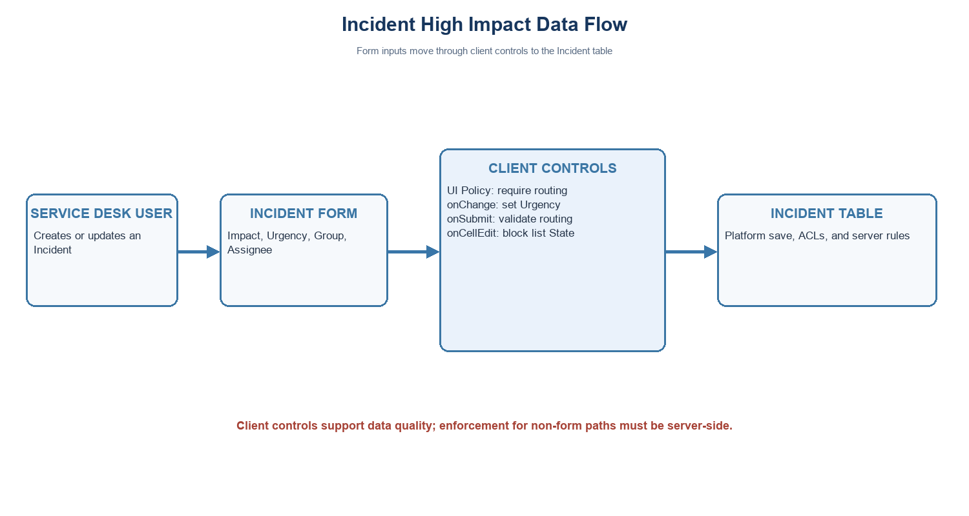
Incident field and save flow
Project note: values use the standard Incident choices where Impact 1 and Urgency 1 represent High. Confirm field names and values in the target instance.

